[SELECT](http://localhost/phpmyadmin/url.php?url=https://dev.mysql.com/doc/refman/8.0/en/select.html" \t "mysql_doc) id\_karyawan, [SUM](http://localhost/phpmyadmin/url.php?url=https://dev.mysql.com/doc/refman/8.0/en/aggregate-functions.html%23function_sum)(jumlah) AS total FROM transaksi\_penjualan GROUP BY id\_karyawan;

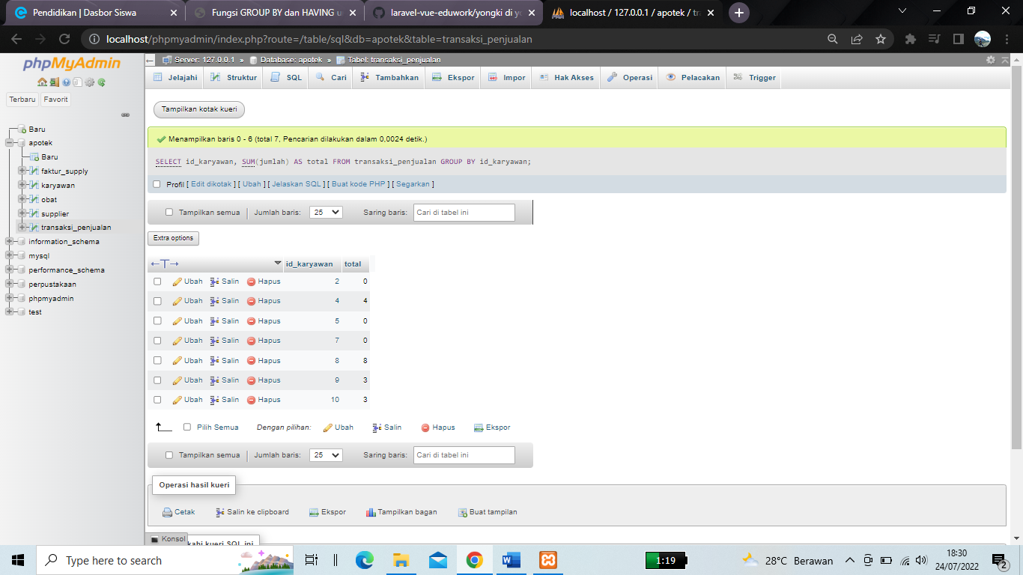

[SELECT](http://localhost/phpmyadmin/url.php?url=https://dev.mysql.com/doc/refman/8.0/en/select.html) id\_obat, [SUM](http://localhost/phpmyadmin/url.php?url=https://dev.mysql.com/doc/refman/8.0/en/aggregate-functions.html%23function_sum)(jumlah) AS total FROM transaksi\_penjualan GROUP BY id\_obat;

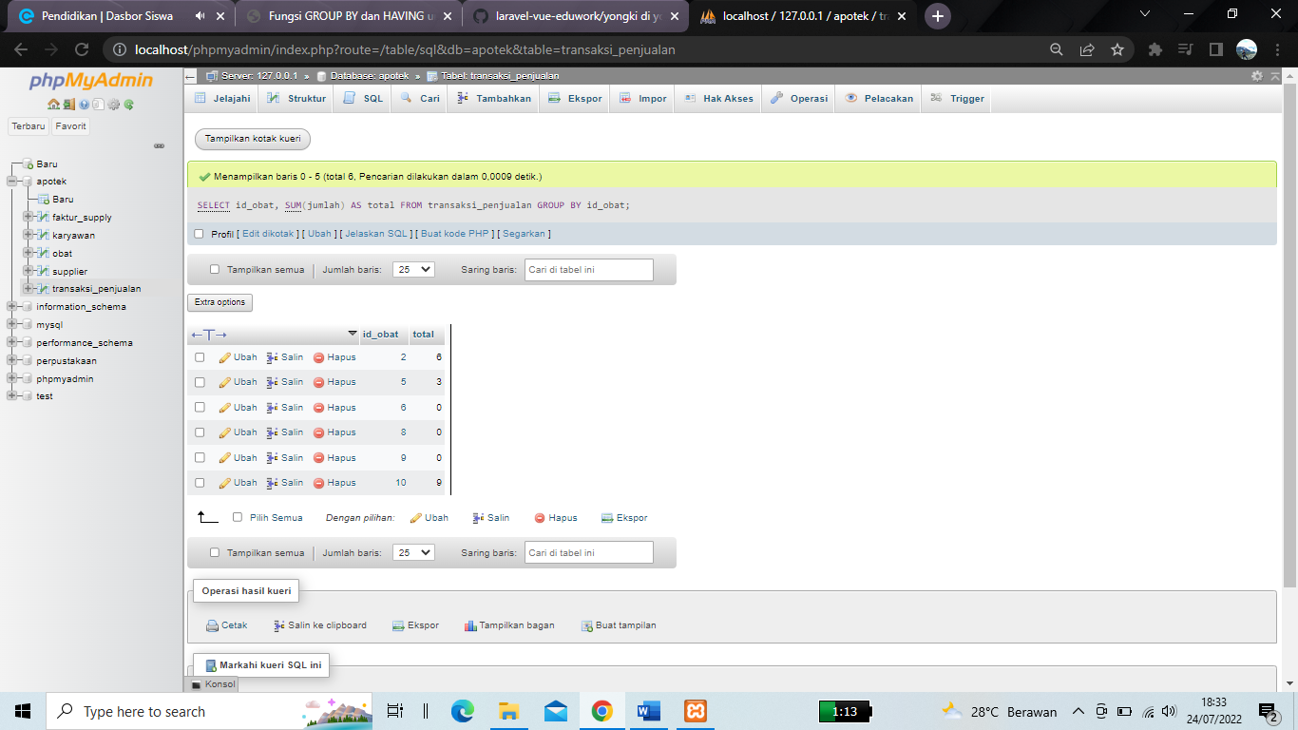

[SELECT](http://localhost/phpmyadmin/url.php?url=https://dev.mysql.com/doc/refman/8.0/en/select.html) id\_supplier, [SUM](http://localhost/phpmyadmin/url.php?url=https://dev.mysql.com/doc/refman/8.0/en/aggregate-functions.html%23function_sum)(jumlah\_obat) AS total FROM faktur\_supply GROUP BY id\_karyawan;

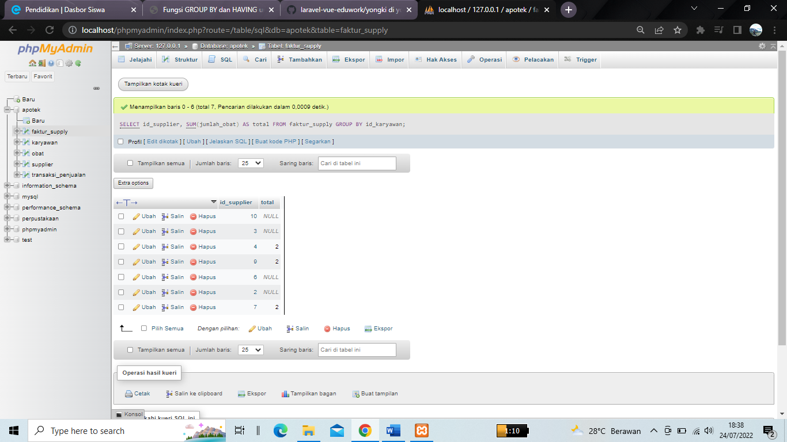

[SELECT](http://localhost/phpmyadmin/url.php?url=https://dev.mysql.com/doc/refman/8.0/en/select.html) \* FROM karyawan ORDER BY nama ASC;

**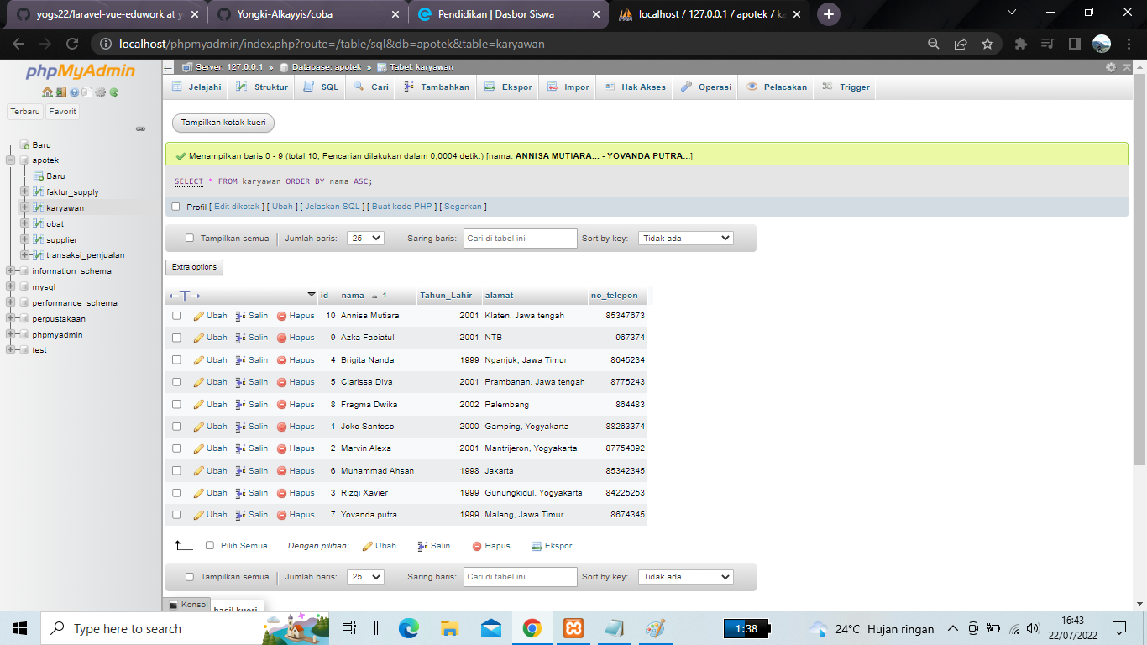**

[SELECT](http://localhost/phpmyadmin/url.php?url=https://dev.mysql.com/doc/refman/8.0/en/select.html) \* FROM karyawan WHERE alamat [LIKE](http://localhost/phpmyadmin/url.php?url=https://dev.mysql.com/doc/refman/8.0/en/string-comparison-functions.html%23operator_like) '%Yogyakarta%'; 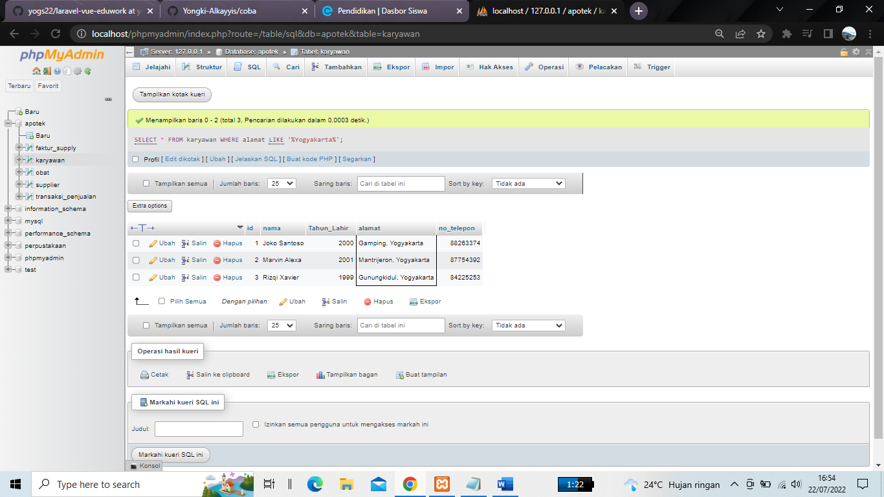

[SELECT](http://localhost/phpmyadmin/url.php?url=https://dev.mysql.com/doc/refman/8.0/en/select.html) \* FROM `transaksi\_penjualan` WHERE jumlah > 2;

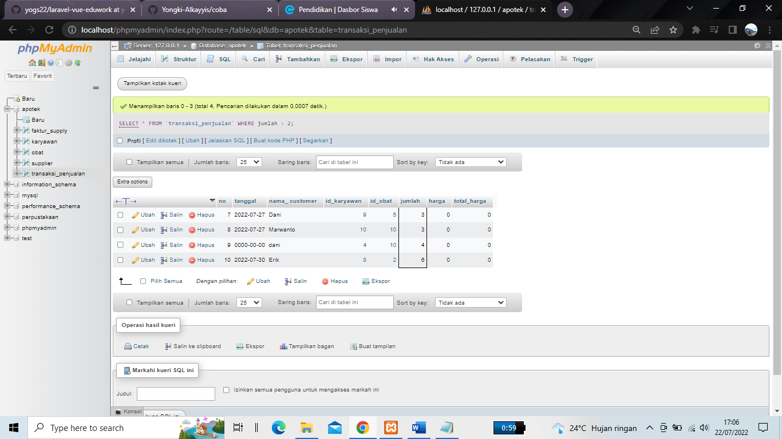

[SELECT](http://localhost/phpmyadmin/url.php?url=https://dev.mysql.com/doc/refman/8.0/en/select.html) nama FROM karyawan WHERE Tahun\_Lahir = 1999;

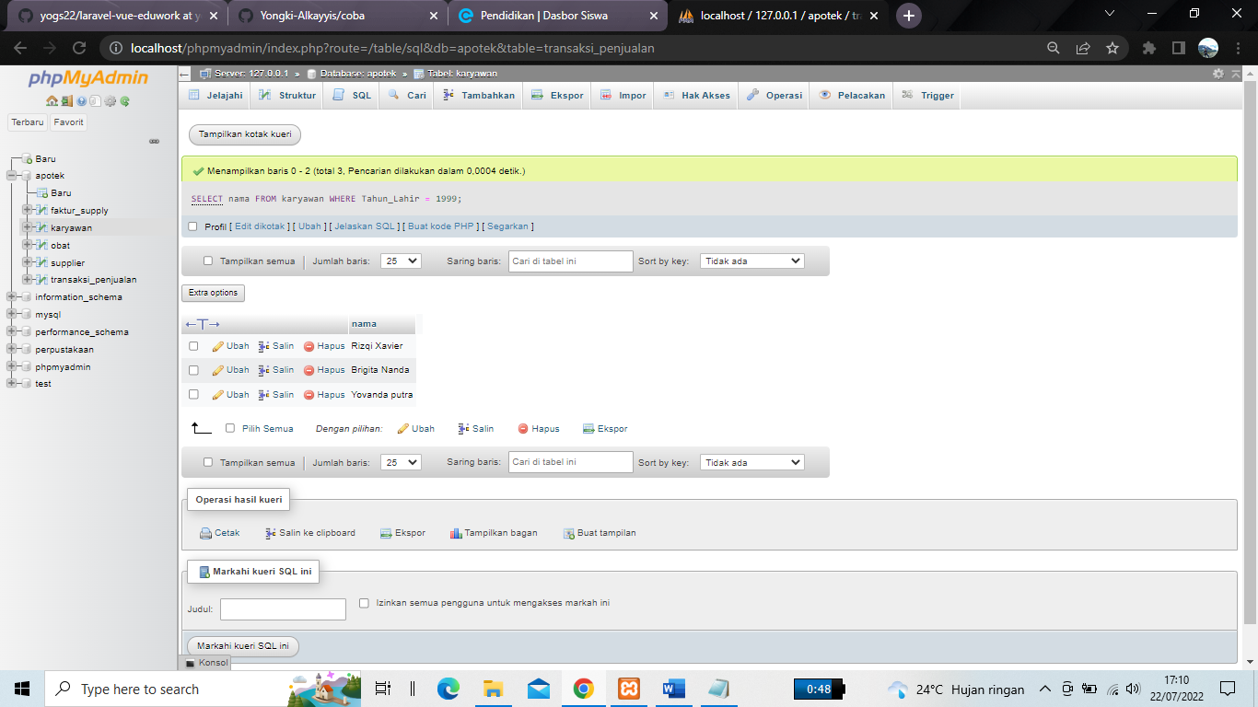

[SELECT](http://localhost/phpmyadmin/url.php?url=https://dev.mysql.com/doc/refman/8.0/en/select.html) \* FROM obat ORDER BY pembuat\_obat;

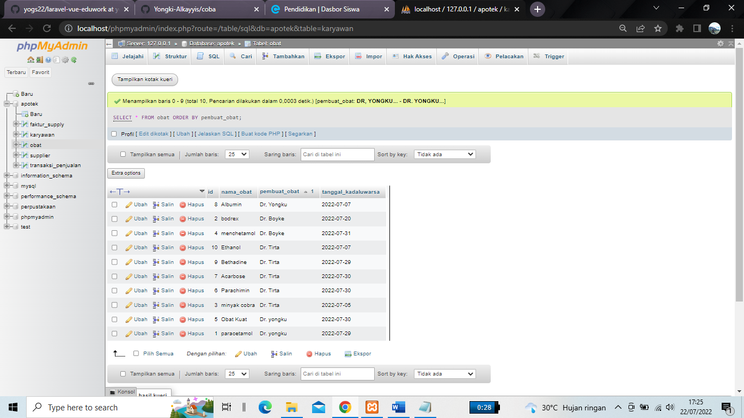

[SELECT](http://localhost/phpmyadmin/url.php?url=https://dev.mysql.com/doc/refman/8.0/en/select.html) nama\_obat FROM obat ORDER By pembuat\_obat DESC;

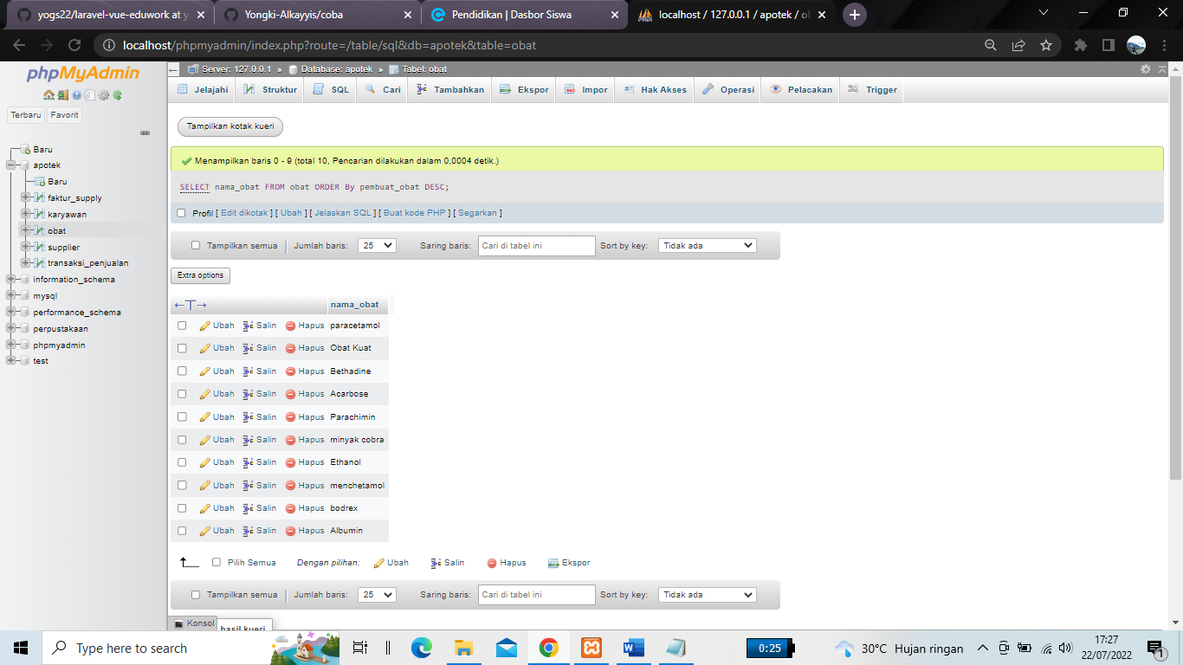

[SELECT](http://localhost/phpmyadmin/url.php?url=https://dev.mysql.com/doc/refman/8.0/en/select.html) \* FROM karyawan WHERE Tahun\_Lahir = '2001'[or](http://localhost/phpmyadmin/url.php?url=https://dev.mysql.com/doc/refman/8.0/en/logical-operators.html%23operator_or) Tahun\_Lahir = '1999'; 